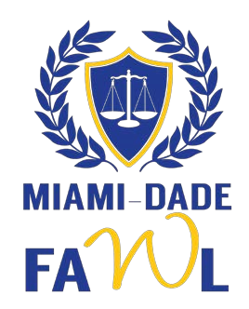
Women Making History Award

Nomination Form Deadline: December 15, 2023, at 5:00 p.m.

The Women Making History Award is awarded annually by the Miami-Dade Chapter of the Florida Association for Women Lawyers during March, which is Women’s History Month. The award recipient exemplifies the ideals of professional achievement, perseverance, and dedication to women's issues. Her accomplishments and passion pave the way for the new women leaders of today's generation. She is a trailblazer.

Nomination Checklist:
- Biographical Information – Please attach a brief biography of the nominee in paragraph or resume format.
- Summary Statement of Qualifications – Section II below
- Personal Impact Statement (Optional) – Section III below
- Supporting Documentation of Nominee’s Accomplishments (Optional)

- Biographical Information

Nominee’s Name:

Email Address: ___________________ Phone Number: _________

Is the nominee aware of her nomination?  Yes  No

Name of Person Submitting Nomination:
Email Address: Phone Number: ____
- Summary Statement. Provide a brief summary of the nominee’s accomplishments (feel free to use additional pages).

- Personal Impact Statement. If desired, provide a brief statement of the impact the nominee has had on the nominator (feel free to use additional pages).

This information may be used for publication and quotations may be attributed to the nominating person from these statements.

Final selection of the award recipient will be made by the MDFAWL Board of Directors. The Women Making History Award will be presented at MDFAWL’s Women Making History Event to be held on March 21, 2024. Nominations must be e-mailed by 5:00 p.m. on December 15, 2023, to the MDFAWL President, Amber Kornreich, at president@mdfawl.org with the subject “MDFAWL WMH Nomination for [Nominee Name].”

